**LIONRA RANNPHAIRTIOCHTA**

**POBAIL LOCH GARMAN**

**WEXFORD PUBLIC**

**PARTICIPATION NETWORK**



**WORKPLAN & BUDGET 2025**

1

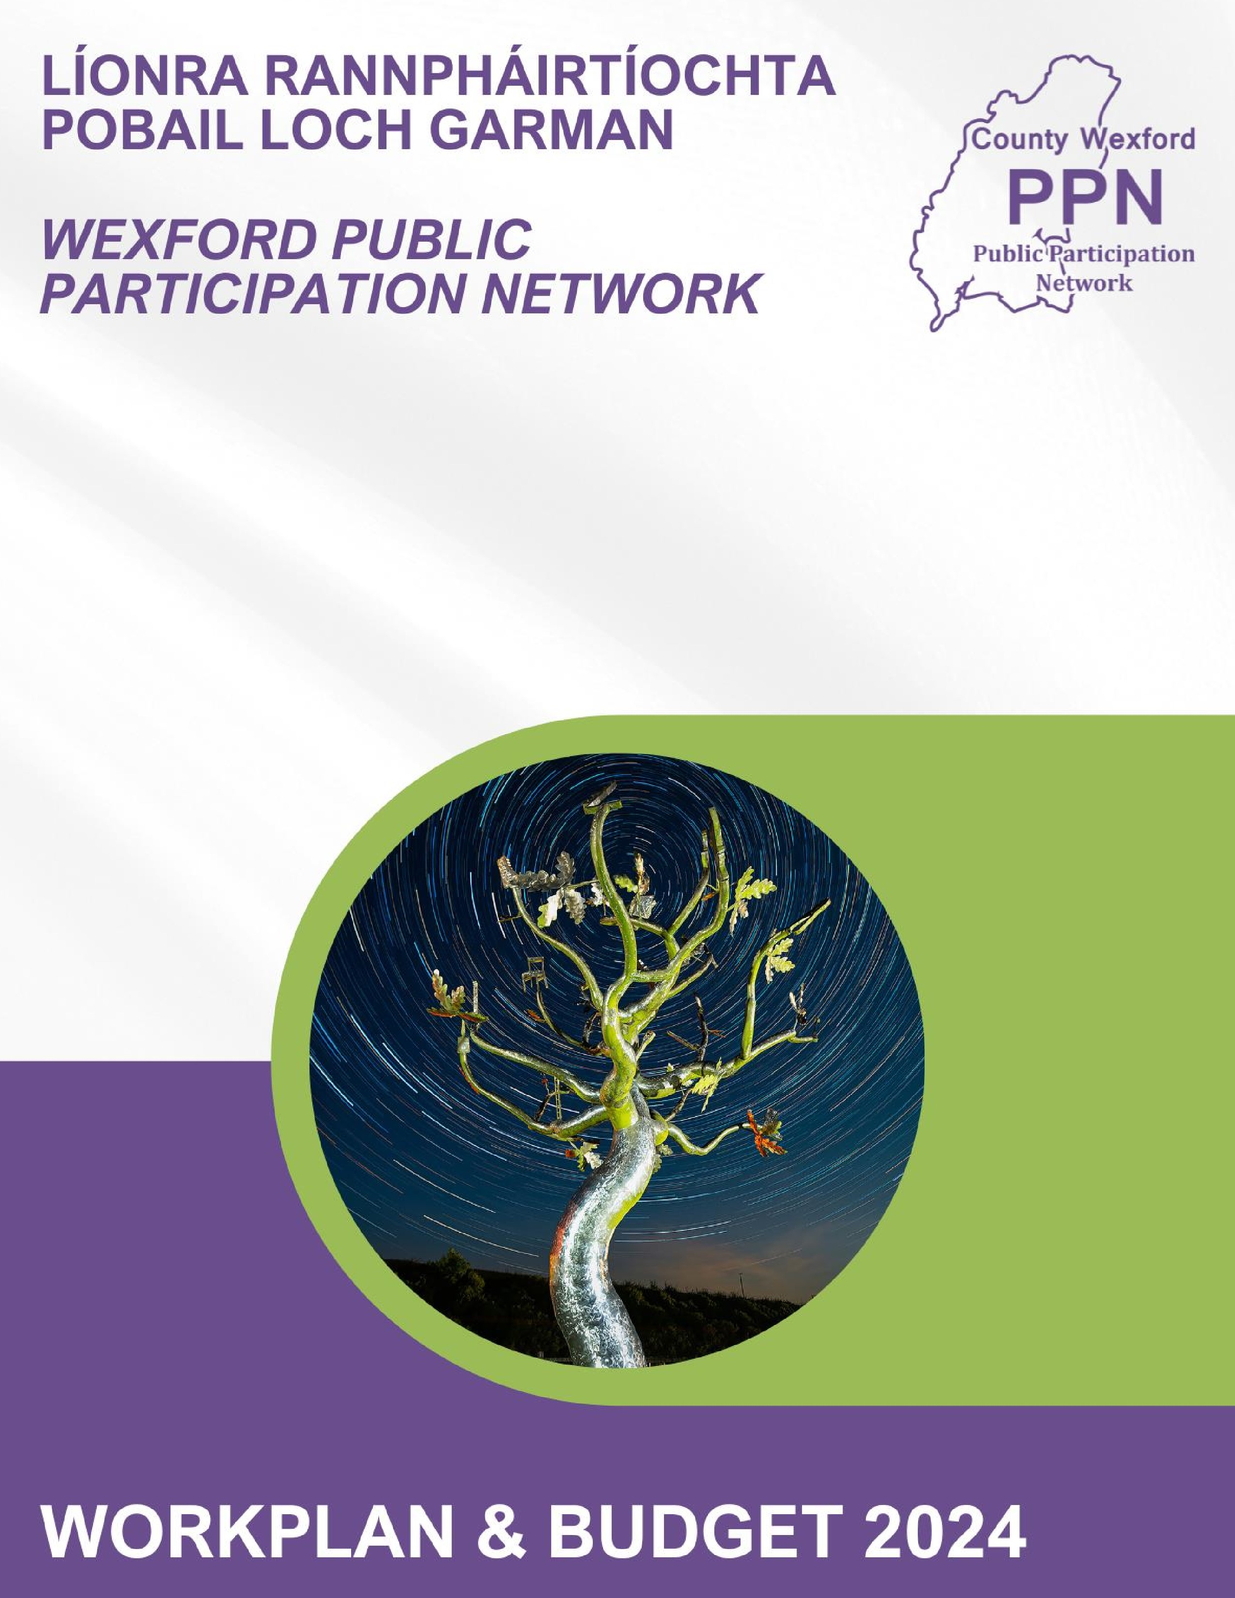

**Wexford PPN – Workplan 2025**

# Introduction

Wexford PPN Secretariat and PPN staff members (Coordinator & Development Officer) worked together to prepare a Workplan and Budget for 2025. This document is a summary of this workplan and budget.



# Background to the Workplan

The workplan takes into consideration the agreed Wexford PPN Vision for Community Wellbeing, Wexford County Council’s Climate Action Plan, and is mindful of the Sustainable Development Goals (SDGs) which Wexford PPN have agreed to support. Objectives and goals for 2025 took into consideration the following key points:

|  |  |
| --- | --- |
| • | Feedback from PPN members. |

|  |  |
| --- | --- |
| • | Objectives set out in the Wexford PPN Strategic Plan 2023-2025. |

|  |  |
| --- | --- |
| • | Allocated Budget. |

|  |  |
| --- | --- |
| • | Ongoing work from 2024. |

|  |  |
| --- | --- |
| • | PPN’s role in Wexford County Council’s Climate Action Plan. |

# Key Aims of the Strategic Plan

The Strategic Plan identifies 4 main themes:

1. Information

1. Development: Communication

1. Development: Training

1. Representation

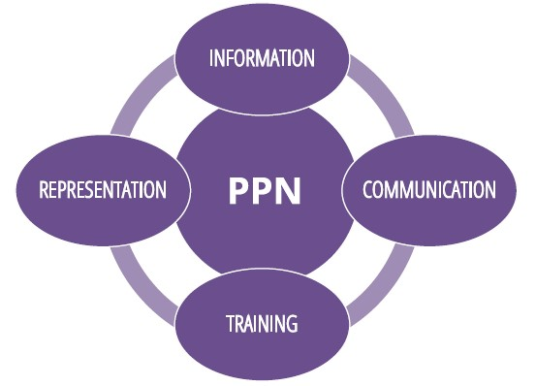

# Objectives & Actions for 2025

Wexford PPN has developed a set of quarterly objectives and actions for 2025. These are aligned to and take consideration of the Strategic Plan goals.

Certain aspects will be recurring across the whole of 2025 and will include:

* Growing the membership of the PPN
* Reviewing and improving the way the PPN delivers information to members – bulletins, website and social media
* Monthly Secretariat meetings
* Promotion of the PPN – 10 Year Celebrations event – promote through radio, newspapers and word of mouth.
* New Capacity Building Training Programme for Secretariat, Representatives and Staff.
* Networking through National and Regional meetings.
* Continue developing Climate Action Linkage Group
* Pursuing the establishment of additional thematic Linkage Groups to benefit PPN members groups.

Unforeseen matters arising, could influence the completing of these objectives as new opportunities and challenges are presented.

There will be a strong focus on sub-committees to assist in the delivery of our ambitious goals for this year.

The Finance Sub-Committee and staff commit to conduct a periodic review of this work plan

(likely at the end of each quarter) and if necessary, any changes to it will be notified to the members of Wexford PPN.

# Quarter 1

|  |  |  |
| --- | --- | --- |
| **Action** | **Responsible** |  |
| Induction training by Social Justice Ireland (8 Modules) to continue for PPN Secretariat, Representatives, Members. |  | Self paced and up to individual |
| MD Secretariat Representatives to arrange and begin hosting meetings for members within their own MD area. March | Development Officer and MD Reps | 3 held  Wexford and New Ross to be held in Q.3 Dates being finalised. |
| Training for all sitting and new and Secretariat Committee members. | Co-Ordinator  Development Officer | Capacity Building Training held on Sat. 5th April |
| Agreement on and the signing of a new Memorandum of Understanding with Wexford County Council. | Secretariat/Wexford County Council | Currently being finalised. |
| Identify and seek nominations for all vacant Secretariat and Representatives positions. | Co-Ordinator  Development Officer | 4 SPC’s position filled. Work progressing on other vacancies |
| Complete and Submit 2024 Financial Report, Workplan & MOU, to DRCD for approval. | Secretariat/Co-Ordinator | Currently being finalised |
| Continue to support and grow the Climate Action Linkage Group | Secretariat/Co-Ordinator | Survey carried out with Climate Action Team and results currently being worked through. |
| Continue to establish a Community Growers Network of Community Gardens in County Wexford through events sponsored by Healthy Wexford | Development Officer/Community & Voluntary Rep |  |
| Reviewing and improving the way the PPN delivers information to members – bulletins, website and social media | Secretariat/Co-Ordinator |  |

**Quarter 2**

|  |  |  |  |
| --- | --- | --- | --- |
| Action | Responsible |  |  |
| Hosting of an in-person Plenary Meeting June 2025 | Secretariat/Co-Ordinator | Finalised |  |
| Completion of the PPN MD Meetings | MD Representatives  Development Officer | 3 held  2 to be held in  July |  |
| Seek nominations for SPC Reps | Co-Ordinator/Development Officer | On-going |  |
| Continue to develop Community Development Toolkit for member groups | Development Officer | On-going |  |
| The Secretariat to host a Reps Round Table meeting | Secretariat | Meetings to be  Held in July |  |
| Training Needs Analysis to be issued to all member groups to plan training for 2025 for members | Co-Ordinator | Will be issued in  July |  |
|  |  |  |  |

**Quarter 3**

|  |  |
| --- | --- |
| Action | Responsible |
| Municipal District Reps to arrange meetings in their areas | MD Reps/Development Officer |
| Promotion of PPN at various summer shows, Gorey Agricultural Show, Bannow Rathangan Show, Castlebridge and Adamstown Show and the National Ploughing Championships | Secretariat/Development Officer |
| Host Community Growers event being sponsored by Healthy Wexford. | Community & Voluntary Rep/Development Officer |
| Commence review of County Wexford PPN Strategic Plan 2023-2025 which is due expire at end of 2025 | Secretariat/Co-Ordinator |
| Re-registration of all member groups through Salesforce Database. New re-registration system is being rolled out by Salesforce. Wexford PPN is pilot county for new system. | Co-Ordinator/Development Officer. |
| Liaising with Representatives on Council Committees to improve reporting back from these meetings to PPN member groups. | Secretariat/Co-Ordinator |
| Training for all sitting and new Representatives | Co-Ordinator/Development Officer |
| Pursuing the establishment of additional thematic Linkage Groups to benefit PPN members groups | Secretariat/Co-Ordinator |

# Quarter 4

|  |  |
| --- | --- |
| **Action** | **Responsible** |
| PPN 10 Year Celebration Event – Promotion of PPN | Secretariat/Co-Ordinator |
| The Secretariat to host a Reps Round Table meeting | Secretariat |
| Considerations for the 2025 Workplan. | Secretariat/Co-Ordinator |
| The holding of a required Plenary meeting. | Secretariat/Co-Ordinator |



# Budget Overview

Wexford PPN is funded by the Department of Rural & Community Development and by Wexford County Council. The available budget is **€135,540** in the calendar year, funded as follows.

* Department of Rural & Community Development (DRCD) will provide five eighths of actual spend to a maximum of €100,540*

*(As per Circular CVSP 3/2024 each PPN will receive an additional €14,840 in core funding from the Department in 2025)*

* Wexford County Council undertakes to provide €35,000.

Wexford PPN use the financial systems of Wexford County Council, and all payments made are handled by Wexford County Council from the ring-fenced budget of €135,540. These amounts are to be used for the purposes of developing and maintaining the PPN.

The most common usage which the Department envisages for the funding would be.

* Staff salaries.
* Expenses incurred by the PPN in carrying out its activities – hosting meetings & events, training workshops, promotional material etc.
* Expenses of the Secretariat.

Wexford PPN and Wexford County Council agree an indicative cost for office space, infrastructure, and materials for PPN Staff, in advance, to allow for Wexford PPN budgeting.

This fee currently is set at €8,000.

|  |  |  |  |
| --- | --- | --- | --- |
| **Circular**  **CVSP**  **3/2024** | **DRCD** | **WEXFORD**  **LA** | **Total Budget** |
| **Core**  **Funding** | €74,840 | €30,000 |  |
| **Support Worker** | €25,700 | €5,000 |  |
|  | €100,540 | €35,000 | €135,540 |

Projected allocations for 2025 and actual expenditure for 2024 shown below.

|  |  |  |
| --- | --- | --- |
| **Budget Item** | **2025**  **Projected Allocations** | **2024**  **Actual Expenditure** |
| Secretariat Travel & Subsistence | €3000 | €1162 |
| PPN Representatives Travel & Subsistence | €500 | €0.00 |
| Hosting Fee to Wexford County Council | €8000 | €8000 |
| Membership of external organisations | €100 | €775 |
| Projects/Activities /Events sponsored by PPN | €500 | €200 |
| IT/Server Support & Maintenance | €400 | €308 |
| Training & Development | €2500 | €0.00 |
| Marketing and Promotion of PPN | €2540 | €181 |
| Plenary/Meeting Costs | €4000 | €2799 |
| Staff Salaries & Travel | € 114,000 | €94386 |
| Website Costs | Nil | **0.00** |
| **TOTAL** | **€135,540** | **€107,811** |

### Please see over/…

### Budget for 2024 €121,928

### Less Expenditure €107,811

Underspend 2024 € 14,116

Carryover request has been made to DRCD for underspend in 2024

Proposed use of carryover funding if allowed by DRCD to be used on following:

* Capacity Building Training for Secretariat, Reps, explore Linkage Groups and desktop re-assessment of Wexford PPN. This project commenced end of 2024 and will be completed in 2025
* Promotional Merchandise not purchased in 2024
* Community Growers Event not run 2024
* Final Stage Payment for Website (carried forward from 2023). Payment now due as new Website is now available.